**12**

**Static Equilibrium and Elasticity**

|  |
| --- |
| **CHAPTER OUTLINE** |

12.1 Analysis Model: Rigid Object in Equilibrium

12.2 More on the Center of Gravity

12.3 Examples of Rigid Objects in Static Equilibrium

12.4 Elastic Properties of Solids

* An asterisk indicates an item new to this edition.

|  |
| --- |
| **SOLUTIONS TO THINK-PAIR-SHARE AND ACTIVITIES** |

**\*TP12.1 Conceptualize** An important thing to notice in the problem statement is that *both* sawhorses are placed the same distance from an end of the plank. Furthermore, the plank is of uniform consistency. Therefore, the system of plank and sawhorses is symmetric about the midpoint of the plank, and we don’t need to worry about which end of the plank represents the origin. The diagram below shows the physical setup.

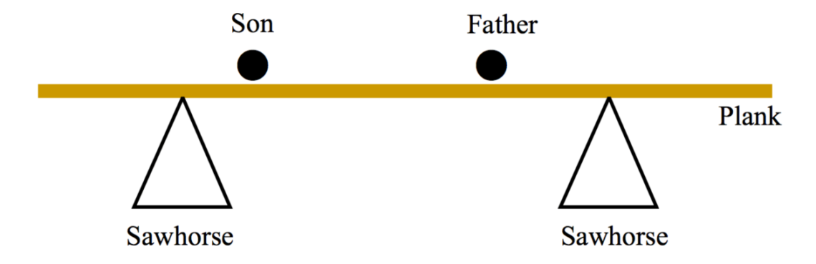

**Categorize** We want the plank to remain in a horizontal position while the father and son move about during their painting activities. Therefore, the plank is modeled as a *rigid object in equilibrium*. It is also a *particle in equilibrium,* since we do not want it moving translationally. We will model the individuals as particles.

**Analyze** To the diagram in the Conceptualize step, let’s add the forces on the plank:

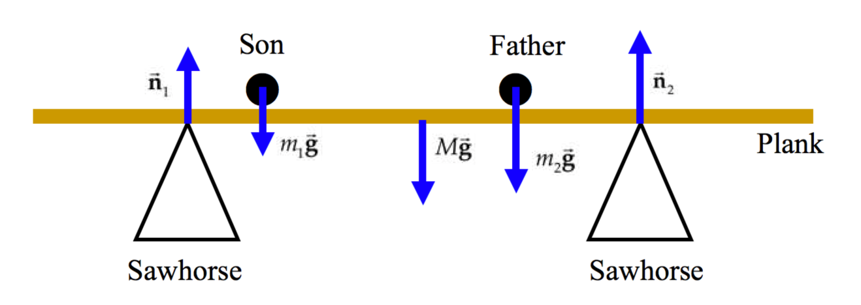

Anticipating that we will be applying the rigid object in equilibrium model to the plank, let’s define a rotation axis at the top of the left-hand sawhorse, which will eliminate one of the normal forces in the torque equation. Let’s add to the diagram the appropriate distances with respect to this rotation axis, knowing that the left-hand sawhorse is 1.00 m from the left end of the plank and that the plank is 3.50 m long:

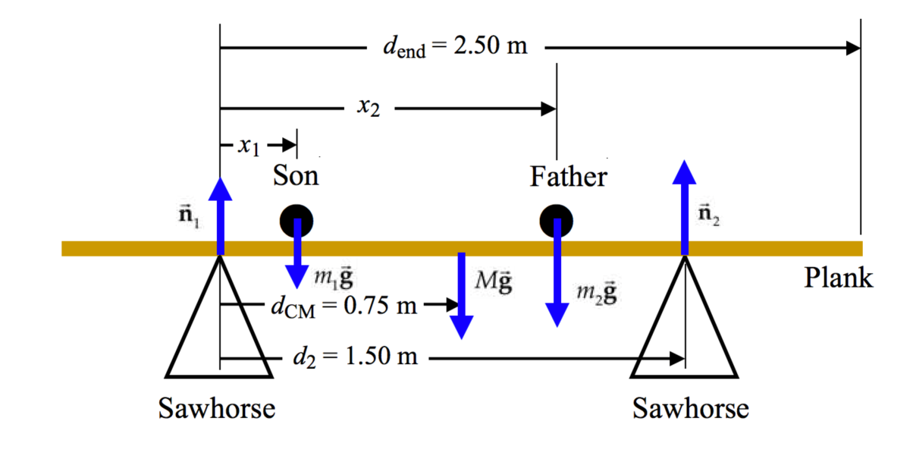

All of the masses are known. The variables in the problem include the positions *x*1 and *x*2 of the father and son and the magnitudes of the normal forces *n*1 and *n*2.

From the particle in equilibrium model applied to the plank, we know that



Write an equation from the rigid object in equilibrium model, remembering that the rotation axis is at the top of the left-hand sawhorse in the diagram:



(a) Place the 85.0-kg father, at the right-hand sawhorse, so *x*2 = *d*2 = 1.50 m. The criterion for the plank tipping is that *n*1 goes to zero for some position of the son on the plank. Solve Equation (1) for the value of *n*2 if *n*1 goes to zero:

 (3)

Now solve Equation (2) algebraically for the position of the son in general:

 (4)

Evaluate this position under the condition that *n*1 = 0, using Equation (3), and simplify:



Substitute numerical values:



**Finalize** Therefore, the father and son are safe as long as the son is to the left of the father, who is at *x*2 = 1.50 m. They are also safe if the son goes a little to the right of the father. But when the son goes to *x*1 = 1.80 m, that is, 0.3 m to the right of the father, the torque around the top of the right-hand sawhorse due to the weight of the plank is not enough to keep the system in equilibrium, and the plank will tip. As long as the son stays off the last 0.7 m of the right end of the plank (when the father is on the right-hand sawhorse), all is safe!

(b) In this part of the problem, we can choose the mass of the plank to be whatever value we want. In particular, we want the minimum value necessary to keep the plank from tipping regardless of where the father and son are standing. The most critical situation would be if both father and son were standing at the far right end of the plank in the figure. That situation is described by *x*1 = *x*2 = *d*end = 2.50 m.

The minimum value of *M* would be found by imagining that the normal force *n*1 just goes to zero as both father and son arrive at the far right end of the plank. Equation (5) provides a relationship for the case in which the normal force *n*1 is equal to zero. Solve this equation for the mass *M* of the plank:



Substitute numerical values:



**Finalize** This is a very heavy plank, but it would provide safety against tipping for the father and son.

(c) Yes. Because of the symmetry of the physical setup, they can stand on either end and be safe. If the plank were not uniform, or if the sawhorses were different distance from the ends of the plank, there would be two different safe masses for the board, depending on which end the father and son stood on together.

(d) Let the damaged sawhorse be the right-hand one in the figure. The maximum value of the normal force *n*2 from that one sawhorse will occur just at the tipping situation, when the normal force *n*1 from the left-hand sawhorse goes to zero.That value of *n*2 is described by

 (3)

Substitute numerical values:



Because this value is less than that required to break the sawhorse, the sawhorse *will* *not* collapse. The father and son still have to be careful about the plank tipping, however.

**Finalize** If we evaluate the normal force required for the right-hand sawhorse when using the *heavy* plank in part (b), we find



This is larger than the breaking force for the sawhorse, so the sawhorse *will* collapse in this case. It is interesting to explore the case of the heavy plank further. For example, if the father stands on the left-hand end of the 180-kg plank, the son can go anywhere on the plank without the right-hand sawhorse collapsing. If the father stands at the right-hand end of the plank, however, the sawhorse collapses before the son even gets on the plank!

*Answers:* (a) no (b) 180 kg (c) yes (d) no

**\*TP12.2 Conceptualize** Imagine in your mind the stack of metersticks, arranged so that they remain at rest on the table, but, when viewed from the side, the top meterstick is entirely off the edge of the table.

**Categorize** The stack of metersticks is modeled as a *rigid object in equilibrium.*

**Analyze** (a) The figure below shows what the metersticks should look like after the hands-on part of the activity:



(b) The particular positions of the metersticks relative to each other may vary from one group to the next, but here is one prescription that works:

(i) Place the bottom meterstick on the table so that the 12.5-cm mark is at the edge of the table and the zero end is in the air.

(ii) Place the second meterstick on top of the first with the zero end in the air and the 16.6-cm mark coinciding with the zero end of the first meterstick.

(iii) Place the third meterstick on top of the second with the zero end in the air and the 25-cm mark coinciding with the zero end of the second meterstick.

(iv) Place the fourth meterstick on top of the third with the zero end in the air and the 50-cm mark coinciding with the zero end of the third meterstick.

Because the metersticks are uniform, each meterstick has its center of mass at the 50-cm mark. From the prescription above, find the position of the center of mass of each meterstick *relative to the edge of the table*:

*x*CM,1 = –37.5 cm

*x*CM,2 = –37.5 cm + 16.6 cm = –20.9 cm

*x*CM,3 = –37.5 cm + 16.6 cm + 25 cm = 4.1 cm

*x*CM,4 = –37.5 cm + 16.6 cm + 25 cm + 50 cm = 54.1 cm

Now use Equation 9.31 to find the center of mass of the combination:



**Finalize** The center of mass is just to the left of the edge of the table, so the stack of metersticks is in equilibrium.

(c) When the top meterstick is rotated as described, its center of mass remains in the same place, above the end of the third meterstick. Therefore, the center of mass of the system remains unchanged and the system remains in equilibrium. While you may think the system will topple because “all of the weight of the fourth stick is applied at the end of the third stick, while only part of its weight was supported there before,” that logic is incorrect.

**Finalize** This final step clearly shows that we can model the meterstick as if all of its mass is concentrated at its center of mass, which has not changed position no matter how the meterstick is rotated.

(d) Let’s find the center of mass of the system of four metersticks. We first number the sticks for identification:

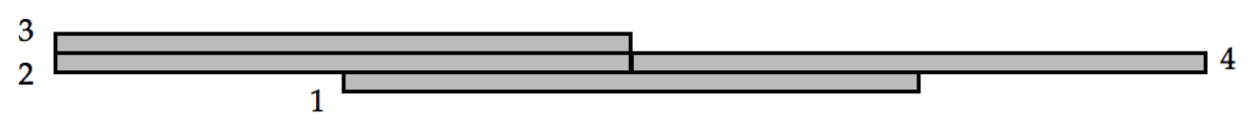

Now determine the center of mass relative to the center of the bottom meterstick:



Therefore, if the zero end of the metersticks are to the right in the figure above, the stack could be balanced by placing it on a table so that the edge of the table is at the 62.5-cm mark on the bottom meterstick.

**Finalize** In this configuration, the right end of meterstick 4 is 112.5 m beyond the edge of the table. In the prescription described in part (b), the right end of the topmost meterstick is only 104.5 cm beyond the edge of the table. Can you figure out a way for the right end of a meterstick to extend even farther beyond the edge of the table?

*Answers:* (a) Answers will vary. (b) Answers will vary. (c) yes (d) 62.5 cm

|  |
| --- |
| **SOLUTIONS TO END-OF-CHAPTER PROBLEMS** |

**Section 12.1 Analysis Model: Rigid Object in Equilibrium**

**\*P12.1 Conceptualize** The arrangement of the boxes will not affect the overall weight being supported by the chains. But it will affect the amount of torque applied to the board by each chain. We can easily conceptualize that the worse situation would be the order 1-2-3, because the lightest box is on the left and the heaviest box is on the right, closest to the defective chain.

**Categorize** The combination of the shelf and the boxes is a *rigid object in equilibrium* (until the chain breaks).

**Analyze** Let us choose to determine torques around the left end of the board. The diagram below shows the physical situation and the important forces. There are three locations, A, B, and C on the shelf in which to place boxes. The three boxes 1, 2, and 3 can be placed in any order in these locations. The mass of each box is identified by location, because any box can go into any given location. The gravitational forces on the three boxes are not drawn to scale, again because the boxes can be placed in any order on the shelf. The distance  is the dimension of each box. Because the boxes are centered across the width of the shelf, each of the two chains at an end of the board will support the same weight, resulting in the coefficients of 2 in the upward forces on the ends of the board.

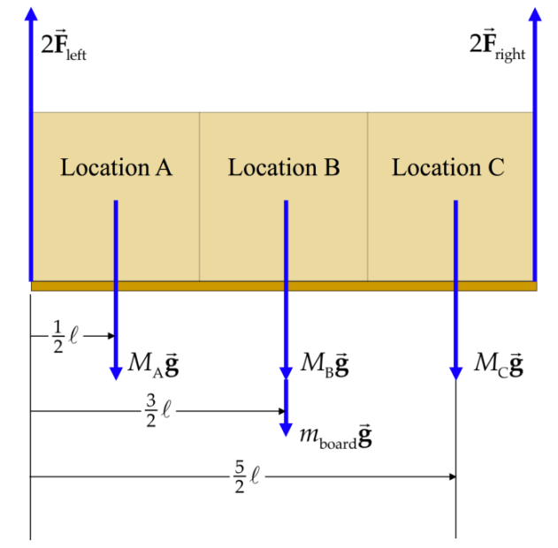

Relative to the left end of the board, write a torque equilibrium equation for the system:



Simplify the equation:



Use this equation to determine the magnitude of the force in each chain on the right for each of the six possible arrangements of the boxes:

|  |  |  |  |  |
| --- | --- | --- | --- | --- |
| **Left-to-Right Arrangement** | ***M*A (kg)** | ***M*B (kg)** | ***M*C (kg)** | ***F*right (N)** |
| 1-2-3 | 50 | 100 | 125 | 821 |
| 1-3-2 | 50 | 125 | 100 | 780 |
| 2-1-3 | 100 | 50 | 125 | 739 |
| 2-3-1 | 100 | 125 | 50 | 617 |
| 3-1-2 | 125 | 50 | 100 | 657 |
| 3-2-1 | 125 | 100 | 50 | 576 |

**Finalize** We see that only three of the arrangements, those in the lower half of the table, are possible without the defective chain breaking.

*Answer:* safe arrangements: 2-3-1, 3-1-2, 3-2-1; dangerous arrangements: 1-2-3, 1-3-2, 2-1-3

**P12.2** Take torques about *P*, as shown in ANS. FIG. P12.2.



We want to find *x* for which 



For the values given:



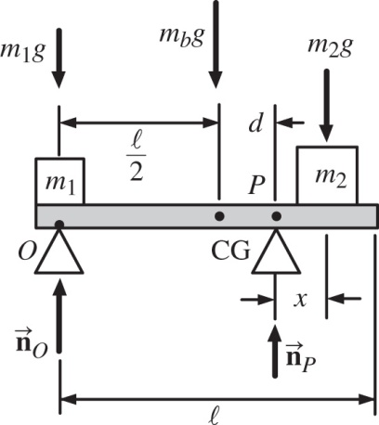

ans. FIG. P12.2



**Section 12.2 More on the Center of Gravity**

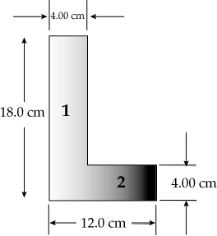**P12.3** The coordinates of the center of gravity of piece 1 are

 and 

The coordinates for piece 2 are

 and 

ans. FIG. P12.3

The area of each piece is

 and 

And the mass of each piece is proportional to the area.

Thus,



and



**P12.4** We can visualize this as a whole pizza with mass *m*1 and center of gravity located at *x*1, plus a hole that hasnegative mass, –*m*2, with center of gravity at *x*2:



Call *σ* the mass of each unit of pizza area.



**\*P12.5 Conceptualize** If the bottom of the sign is to hang in the horizontal orientation shown in Figure P12.5, the sign must be hung from a point directly above its center of gravity, which is the same point as its center of mass.

**Categorize** This is a problem in which we must find the center of mass of a continuous object.

**Analyze** The *z* component of the center of mass will be at *z* = 2.50 cm, that is, halfway through the thickness *t* of the sign, because the material is uniform. We don’t need the *y* component, because the position at which we attach the wire does not depend on the height of the center of mass above the *x* axis.

To find the *x* component of the center of mass, identify a strip of material perpendicular to the *x* axis as shown in the diagram below:

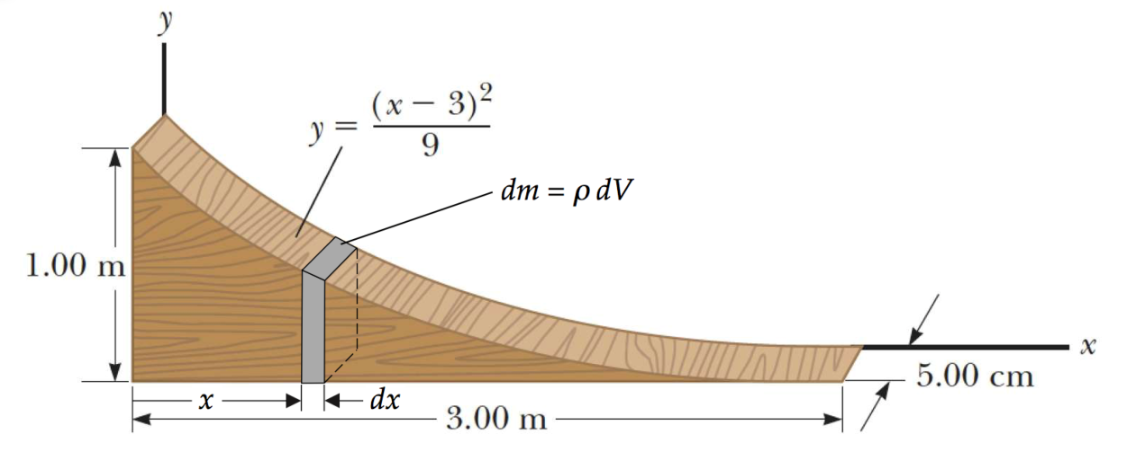

In the diagram, we have identified ** as the mass density of the material. Begin with Equation 9.32:

 (1)

The mass *M* can be found by integrating:

 (2)

The volume element *dV* is the volume of the gray slice of the sign shown in the diagram above:

 (3)

where *t* is the uniform thickness of the sign in the *z* direction. Combining Equations (2) and (3), find the mass of the sign:



Find the center of mass from Equations (1) and (4):



**Finalize** The wire should be attached to the sign halfway through its thickness and at a distance *x* = 0.750 m from the origin, which is just about at the location of the gray slice in the diagram.

We were a little loose with the units in this solution in order to keep things clean-looking, but you can have confidence that it all works out. The function for *y* can be written more precisely as



Therefore, the 3s and 9s in the integrations above carry units. This leads to odd things such as the mass *M* being expressed as *t* in Equation (4); think about the units on each side of Equation (4)! Better to leave the units out!

Answer: *x* = 0.750 m

**P12.6** Since the beam is in equilibrium, we choose the center as our pivot point and require that



or

 **[1]**

Also,

 **[2]**

Substitute equation [1] into [2] to get the following:

 or 

Then, equation [1] yields 



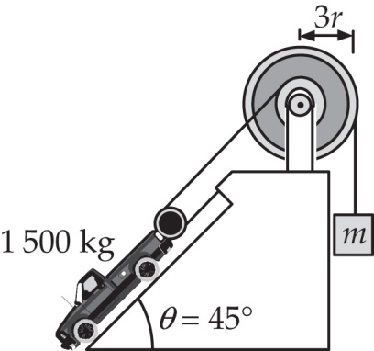**P12.7** The second condition for equilibrium at the pulley is

 **[1]**

and from equilibrium at the truck, we obtain



ans. FIG. P12.7

solving for the mass of the counterweight from [1] and substituting gives



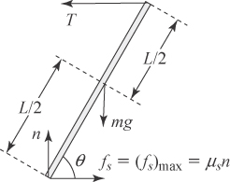**P12.8** (a) See the force diagram shown in ANS. FIG. P12.8.

(b) Select a pivot point where an unknown force acts so that the force has no torque about that point. Picking the lower end of the beam eliminates torque from the

normal force, *n*, and the friction force, *f*.

ans. FIG. P12.8



or



(c) From the first condition for equilibrium,

 or  **[1]**

 **[2]**

Substitute equation [2] into [1] to obtain 

(d) Equate the results of parts (b) and (c) to obtain 

This result is valid only at the critical angle *θ* where the beam is on the verge of slipping (i.e., where *fs* = (*fs*)max is valid).

(e)  When the base of the ladder is moved to the left, the angle *θ* decreases. According to the result in part (b), the tension *T* increases. This requires a larger friction force to balance *T*, but the static friction force is already at its maximum value in ANS. FIG. P12.8.

**P12.9** (a) Vertical forces on one-half of the chain are





(b) Horizontal forces on one-half of the chain are





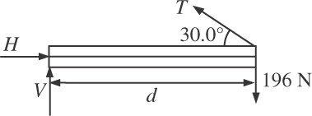**P12.10** (a) See the force diagram in ANS. FIG. P12.10.

(b) The mass *M* of the beam is 20.0 kg. We consider the torques acting on the beam, about an axis perpendicular to the page and through the left end of the horizontal beam.

**ans. FIG. P12.10**



(c) From  

or 

(d) From  ,

or 

(e) From the same free-body diagram with the axis chosen at the right-hand end, we write



(f) From  ,

or 

(g) From  

or 

(h) 

**P12.11** The bridge has mass *M* = 2 000 kg and the knight and horse have mass *m* = 1 000 kg. Relative to the hinge end of the bridge, the cable is attached horizontally out a distance  and vertically up a distance  The cable then makes the following angle with the vertical wall:



Call the force components at the hinge *Hx* (to the right) and *Hy* (upward).

(a) Take torques about the hinge end of the bridge:



which yields 

(b) 

or 

(c) 

Thus,



**P12.12** (a) 

From the result of (b) below, the tangential acceleration of the point where the horse stands is



which has a vertical component  greater than the acceleration of gravity.

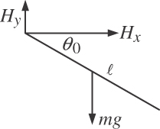 (b) Assuming that the bridge does fall from under the horse, its angular acceleration will be caused by torque from the weight of the bridge—if the bridge does not fall out from under the horse, there will be additional   
torque from the weight of the knight and   
horse, and the acceleration will be greater.

ans. FIG. P12.12 (b)



As cited in part (a), this results in the bridge falling out from under the horse, so our assumption was justified.

(c) Because there is no friction at the hinge, the bridge-Earth system is isolated, so mechanical energy is conserved. When the bridge strikes the wall:



which gives



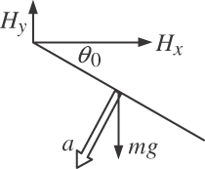 (d) The tangential acceleration of the center of mass of the bridge is



ans. FIG. P12.12 (d)

which is directed 20.0° below the   
horizontal. By Newton’s second law:

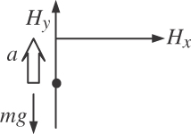  

(e) When the bridge strikes the wall, *Hx* = 0 and   
the hinge supplies a vertical centripetal force:

ans. FIG. P12.12 (e)



**P12.13** (a) In Figure P12.13, let the “Single point of contact” be point *P*, the force the nail exerts on the hammer claws be *R*, the mass of the hammer (1.00 kg) be *M*, and the normal force exerted on the hammer at point P be n, while the horizontal static friction exerted by the surface on the hammer at P be *f*.

Taking moments about *P*,



The force exerted by the hammer on the nail is equal in magnitude and opposite in direction:



(b) From the first condition for equilibrium,







**P12.14** (a) The force diagram is shown in ANS. FIG. P12.14.

(b) From 



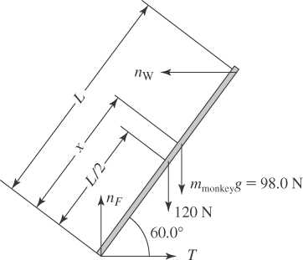

ans. FIG. P12.14

(c) When *x* = 2*L*/3, we consider the bottom end of the ladder as our pivot and obtain



or 

Then,  or 

(d) When the rope is ready to break,  Then  yields



or 

(e) If the horizontal surface were rough and the rope removed, a horizontal static friction force directed toward the wall would act on the bottom end of the ladder. Otherwise, the analysis would be much as what is done above. The maximum distance the monkey could climb would correspond to the condition that the friction force have its maximum value,  so you would need to know the coefficient of static friction between the ladder and the floor to solve part (d).

**P12.15** Call the required force *F*, with components  and  transmitted to the center of the wheel by the handles.

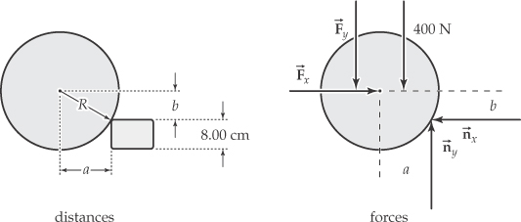

ans. FIG. P12.15

Just as the wheel leaves the ground, the ground exerts no force on it.

 [1]

 **[2]**

Take torques about its contact point with the brick. The needed distances are seen to be:



(a)  or



so 

(b) Then, using equations [1] and [2],

 and





**P12.16** Call the required force *F*, with components  and  transmitted to the center of the wheel by the handles.

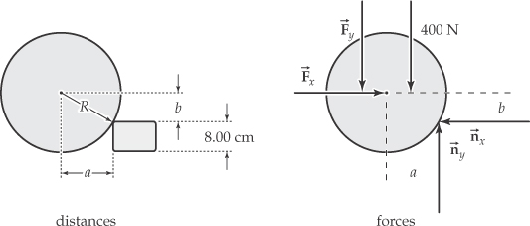

ans. FIG. P12.16

Just as the wheel leaves the ground, the ground exerts no force on it.

 **[1]**

 **[2]**

Take torques about its contact point with the brick. The needed distances are seen to be:



(a)  or



(b) Then, using equations [1] and [2],



and 

**Section 12.4 Elastic Properties of Solids**

**P12.17** We use .

(a) 

(b) The quantity of water with mass  occupies volume at the bottom: 

So its density is  

(c) 

**P12.18** Count the wires. If they are wrapped together so that all support nearly equal stress, the number should be



Since cross-sectional area is proportional to diameter squared, the diameter of the cable will be



**P12.19** From the defining equation for the shear modulus, we find  as



or 

**P12.20** The definition of Young’s modulus,  means that *Y* is the slope of the graph:



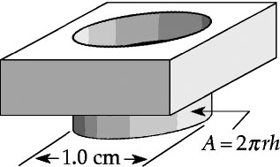**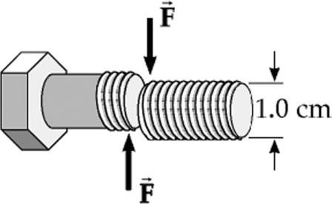P12.21** (a) From ANS. FIG. P12.31(a), **

ANS. FIG. P12.21(a)

(b) Now the area of the molecular layers sliding over each other is the curved lateral surface area of the cylinder being punched out, a cylinder of radius 0.500 cm and height 0.500 cm. So,



ANS. FIG. P12.21(b)

**P12.22** Let *V* represent the original volume. Then, 0.090 0*V* is the change in volume that would occur if the block cracked open. Imagine squeezing the ice, with unstressed volume 1.09*V*, back down to its previous volume, so  = –0.090 0*V*. According to the definition of the bulk modulus as given in the chapter text, we have



**P12.23** A particle under a net force model:



Hence,



By Newton’s third law, this is also the magnitude of the average force exerted on the spike by the hammer during the blow. Thus, the stress in the spike is

Stress 

and the strain is

strain 

**Additional Problems**

**P12.24** (a) 

(b) ANS. FIG. P12.24 shows the free-body diagram.

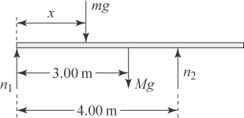

**ANS. FIG. P12.24**

*Mg* = (90.0 kg)*g* = 882 N, and *mg* = (55.0 kg)*g* = 539 N.

(c) Note that about the right pivot, only *n*1 exerts a clockwise torque, all other forces exert counterclockwise torques except for *n*2 which exerts zero torque. The woman is at *x* = 0 when *n*1 is greatest. With this location of the woman, the counterclockwise torque about the center of the beam is a maximum. Thus, *n*1 must be exerting its maximum clockwise torque about the center to hold the beam in rotational equilibrium.

(d)  As the woman walks to the right along the beam, she will eventually reach a point where the beam will start to rotate clockwise about the rightmost pivot. At this point, the beam is starting to lift up off of the leftmost pivot and the normal force exerted by that pivot will have diminished to zero.

(e) When the beam is about to tip, *n*1 = 0, and

 gives 0 + *n*2 – *Mg* – *mg* = 0, or



(f) Requiring that the net torque be zero about the right pivot when the beam is about to tip (n1 = 0) gives



or  and



Thus, 

(g) When n1 = 0 and n2 = 1.42 × 103 N, for torque about the left pivot:



or 

which, within limits of rounding errors, is

.

**P12.25** Let *nA* and *nB* be the normal forces at the points of support. Then, from the translational equilibrium equation in the *y* direction, we have



Choosing the axis at point *A*, we find, from the condition for rotational equilibrium:



We can solve the torque equation directly to find



Then the force equation gives



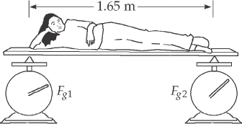**P12.26**  



Take torques about her feet:

 

**ANS. FIG. P12.26**



**P12.27** When the concrete has cured and the pre-stressing tension has been released, the rod presses in on the concrete and with equal force, *T*2, the concrete produces tension in the rod.

(a) In the concrete:

stress 

Thus,



or 

(b) In the concrete:



so



(c) For the rod:

 so 



(d) The rod in the finished concrete is 2.00 mm longer than its unstretched length. To remove stress from the concrete, one must stretch the rod 0.400 mm farther, by a total of .

(e) For the stretched rod around which the concrete is poured:



**P12.28** (a) See ANS. FIG. P12.28 for the force diagram. See the solution in the textbook. The weight of the uniform gate is 392 N. It is 3.00 m wide. The hinges are separated vertically by 1.80 m. The bucket of grain weighs 50.0 N. One of the hinges, which we suppose is the upper one, supports the whole weight of the gate. Find the components of the forces that both hinges exert on the gate.

(b) From the torque equation,



Then *A* = 410 N. Also *B* = 442 N.



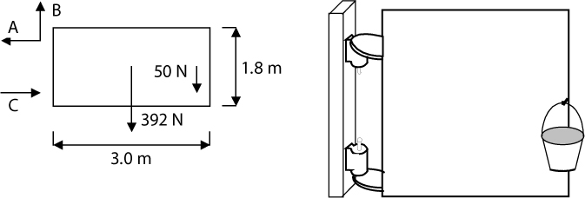

**ANS. FIG. P12.28**

**P12.29** (a) ANS. FIG. P12.29 shows the force diagram.

(b)If *x* = 1.00 m, then



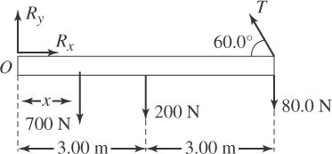

**ANS. FIG. P12.29**

Solving for the tension gives: 

From  

From  

(c) If *T* = 900 N:



Solving for *x* gives 

**P12.30** ANS. FIG. P12.30 shows the force diagram.

 gives

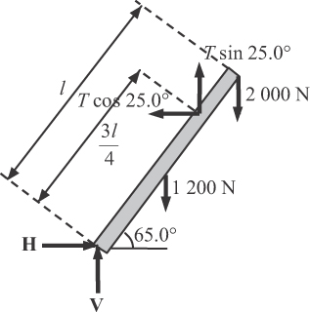

**ANS. FIG. P12.30**



From which, 

From 



From 



**P12.31** We know that the direction of the force from the cable at the right end is along the cable, at an angle of *θ* above the horizontal. On the other end, we do not know magnitude or direction for the hinge force  so we show it as two unknown components.

The first condition for equilibrium gives two equations:



Taking torques about the left end, we find the second condition is



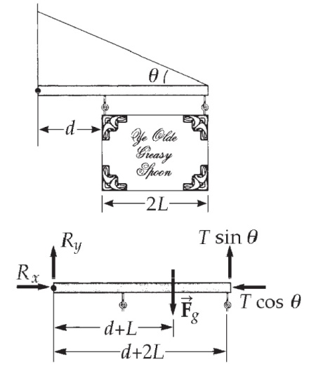

**ANS. FIG. P12.31**

(a) The torque equation gives 

(b) Now from the force equations,

 and 

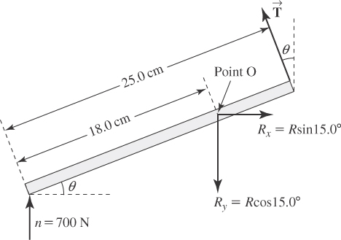**P12.32** In the free-body diagram of the foot given at the right, note that the force  (exerted on the foot by the tibia) has been replaced by its horizontal and vertical components. Employing both conditions of equilibrium (using point O as the pivot point) gives the following three equations:

**ANS. FIG. P12.32**



or  **[1]**

** [2]**



or  **[3]**

Substituting equation [3] into equation [1] gives

 **[4]**

Substituting equations [3] and [4] into equation [2] yields



which reduces to: 

Squaring this result and using the identity  gives



In this last result, let  and evaluate the constants to obtain the quadratic equation:



The quadratic formula yields the solutions *u* = 0.869 3 and *u* = 0.0117. Thus,

 or 

We ignore the second solution since it is physically impossible for the human foot to stand with the sole inclined at 83.8° to the floor. We are the left with .

Equation [3] then yields



and equation [1] gives



**P12.33** From ANS. FIG. P12.33, the angle  makes with the rod is *θ* = 60.0°+ 20.0° = 80.0° and the perpendicular component of  is *T* sin 80.0°. Summing torques around the base of the rod, and applying Newton’s second law in the horizontal and vertical directions, we have

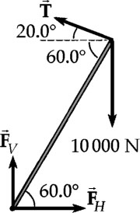 

(a) Solving the above equation for *T* gives



**ANS. FIG. P12.33**

(b) In the horizontal direction,



so 

(c) From

we find



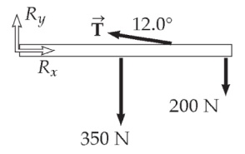**P12.34** (a) Choosing torques about the hip joint,  gives



**ANS. FIG. P12.34**

From which, .

(b) Let  compression force along spine, and from



(c) 

(d) 

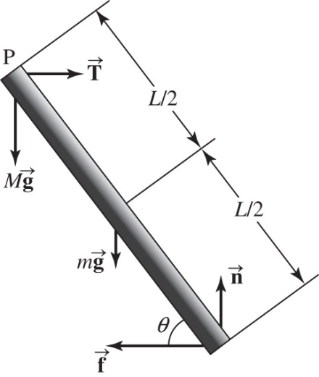**P12.35** (a) We use  and   
choose the axis at the point of contact   
with the floor to simplify the torque   
analysis. Since the rope is described as   
very rough, we will assume that it will   
never slip on the end of the beam. First,   
let us determine what friction force at   
the floor is necessary to put the system   
in equilibrium; then we can check   
whether that friction force can be   
obtained.

**ANS. FIG. P12.35**



Solving the torque equation, we find 

Then the horizontal-force equation implies by substitution that this same expression is equal to *f*. In order for the beam not to slip, we need  Substituting for *n* and *f* from the above equations*,* we obtain the requirement



The factor in brackets is always < 1, so if  then *M* can be increased without limit. In this case, there is no maximum mass! Otherwise, if  the equality will apply on the verge of slipping, and solving for *M* yields



(b) At the floor, we see that the normal force is in the *y* direction and the friction force is in the –*x* direction. The reaction force exerted by the floor then has magnitude



(c) At point *P*, the force of the beam on the rope is in magnitude



**P12.36** The cabinet has height  width *w* = 0.600 m, and weight   
Mg = 400 N. The force *F* = 300 N is applied by the worker in the first case at height *h*1 = 0.100 m and in the second at height *h*2 = 0.650 m.

Consider the magnitudes of the torques about the lower right front edge of the cabinet from the weight *Mg* and from the applied force *F* for the two values of *h*. The torque from the weight is the same in each case:

Cases 1 and 2



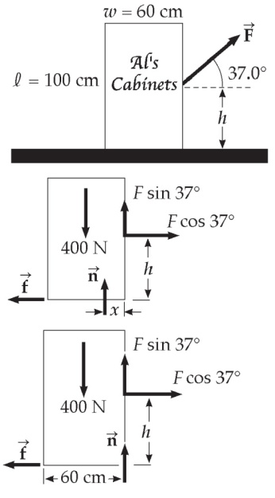 The torque from force *F* is different in each case:

Case 1



Case 2



**ANS. FIG. P12.36**

We see in Case 1 that the counterclockwise torque from the weight is greater than the clockwise torque from the applied force. If the cabinet is to slide without acceleration, the net torque must be zero; this is possible because the normal force from the floor can provide additional clockwise torque. We see in Case 2, however, that the counterclockwise torque from the weight is smaller than the clockwise torque from the applied force, but no other force is available to provide addition counterclockwise torque, so the net torque cannot be zero.



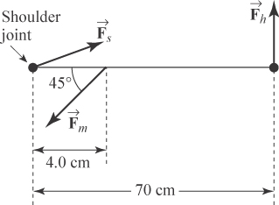**P12.37** (a) From the symmetry of the situation, we may conclude that the magnitude of the upward force on each hand is half the weight of the athlete: *Fh* = 750 N/2 = 375 N. Considering the shoulder joint as the pivot, the second condition of equilibrium gives

**ANS. FIG. P12.37**



or 

(b) The moment arm of the force is no longer 70.0 cm from the shoulder joint but only 49.5 cm:



therefore reducing *Fm* to 6.56 kN.

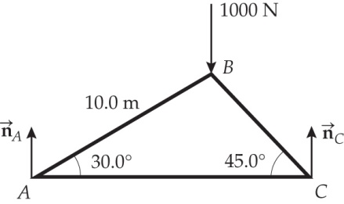**P12.38** (a) The height of pin *B* is



The length of bar *BC* is then



**ANS. FIG. P12.38 (a)**

Consider the entire truss:



Which gives 

Then, 

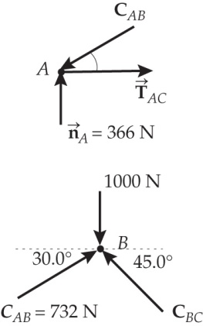 (b) Joint *A*:  

so 







**ANS. FIG. P12.38 (b)**

Joint *B*:





**P12.39** Considering the torques about the point at the bottom of the bracket yields:



(a) With *W* = 80.0 N, .

(b) Differentiate with respect to time: 

Given that *dW*/*dt* = 0.150 N/s:



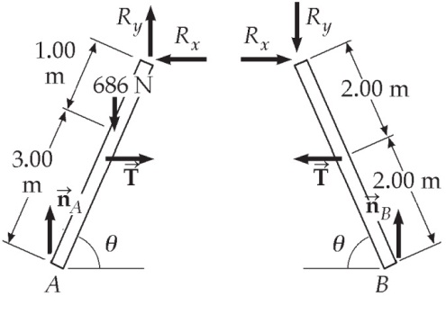**P12.40** Refer to the solution to P12.41 for a general discussion of the solution.

From the geometry of the ladder, observe that



**ANS. FIG. P12.40**

In the following, we use the variables *m* = 70.0 kg, length  and *d* = 3.00 m.

Consider the net torque about point *A* (on the bottom left side of the ladder) from external forces on the whole ladder. The torques about *A* come from the weight of the painter and the normal force *nB*.



Consider the net torque about point *B* (on the bottom right side of the ladder) from external forces on the whole ladder. The torques about *B* come from the weight of the painter and the normal force *nA*.



Consider the torque from external forces about point *C* at the top of the right half of the ladder:



Note that the tension *T* on the right half of the ladder must pull to the left, otherwise it could not contribute a clockwise torque about *C* to balance the counterclockwise torque from *n*B.

Now we find the components of the reaction force that the left half of the ladder exerts on the right half. Consider the forces acting on the right half of the ladder:



Collecting our results, we find

(a) 

(b) 



and



(c) The force exerted by the left half of the ladder on the right half is to the right and downward:



and 

**P12.41** From the geometry of Figure P12.40 and ANS. FIG. P12.40, we observe that



and



(a) Below in part (b) we show that normal force  We use this result here to find the tension *T* in the horizontal bar.

Consider the torque about point *C* at the top of the right half of the ladder:



Note that the tension T on the right half of the ladder must pull to the left, otherwise it could not contribute a clockwise torque about *C* to balance the counterclockwise torque from *nB*.

(b) We now proceed to find the normal forces *nA* and *nB*.

First, consider the net torque from all forces acting on the ladder about point *B* at the bottom right side of the whole ladder. Note that tension *T* on the left half of the ladder and tension *T* on the right half of the ladder have opposite torques because they have the same moment arms about point *B*, so their torques cancel (they are forces internal to the system, so they cannot contribute to net torque). In like manner, torques from *R*x and *R*y on both halves of the ladder cancel in pairs (again, they are internal forces). The only contributing torques come from the weight of the painter and the normal force *nA* (these are forces external to the ladder).



Now, consider the net torque from all forces acting on the ladder about point *A* on the bottom left side of the whole ladder. Similarly to the case of the torques about point *B*, the only contributing torques about *A* come from the weight of the painter and the normal force *nB* (again, these are external forces).



(c) Now we find the components of the reaction force that the left half of the ladder exerts on the right half. Consider the forces acting on the right half of the ladder:



**P12.42** We will let *F* represent some stretching force and use algebra to combine the Hooke’s-law account of the stretching with the Young’s-modulus account. Then integration will reveal the work done as the wire extends.

(a) According to Hooke’s law, 

Young’s modulus is defined as 

By substitution,



(b) The spring exerts force –*kx*. The outside agent stretching it exerts force +*kx*. We can determine the work done by integrating the force *kx* over the distance we stretch the wire.



Therefore,



**P12.43** (a)Take both balls together. Their weight is 2*mg* = 3.33 N and their CG is at their contact point.



For torque about the contact point (CP) between the balls:



Substituting P3 = P1, we find



Therefore,



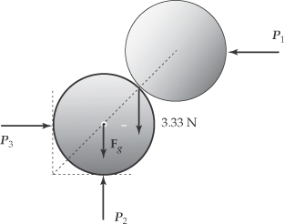

**ANS. FIG. P12.43 (a)**

(b) Take the upper ball. The lines of action of its weight, of , and of the normal force *n* exerted by the lower ball all go through its center, so for rotational equilibrium there can be no frictional force.

 



  gives the same result.

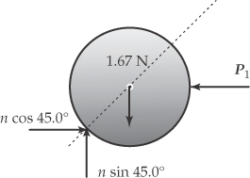

**ANS. FIG. P12.43 (b)**

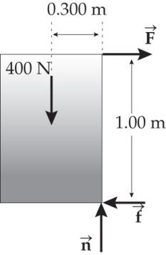**P12.44** (a), (b) Use the first diagram and sum the torques about the lower front corner of the cabinet.



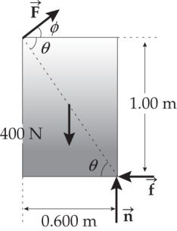 yielding 

 or 



so Thus,

**ANS. FIG. P12.44**



(c) Apply *F*’ at the upper rear corner and directed so  to obtain the largest possible lever arm.



Thus, 

Sum the torques about the lower front corner of the cabinet:



so 

Therefore, the minimum force required to tip the cabinet is



**P12.45** Let *θ* represent the angle of the wire with the vertical. The radius of the circle of motion is , where *L* = 0.850 m.

**ANS. FIG. P12.45**

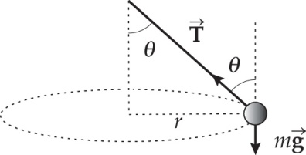 For the mass: 

Further,  or 

Thus,  giving



or 

**\*P12.46 Conceptualize** It is likely that you have had the experience of lifting one end of a long box to tilt the box up to stand on end. Think about that experience.

**Categorize** Assume that the heavy crate is lifted very slowly so that we can model it as a *rigid object in equilibrium* at a given time.

**Analyze** The drawing below shows the crate at an arbitrary instant during the process of lifting it.

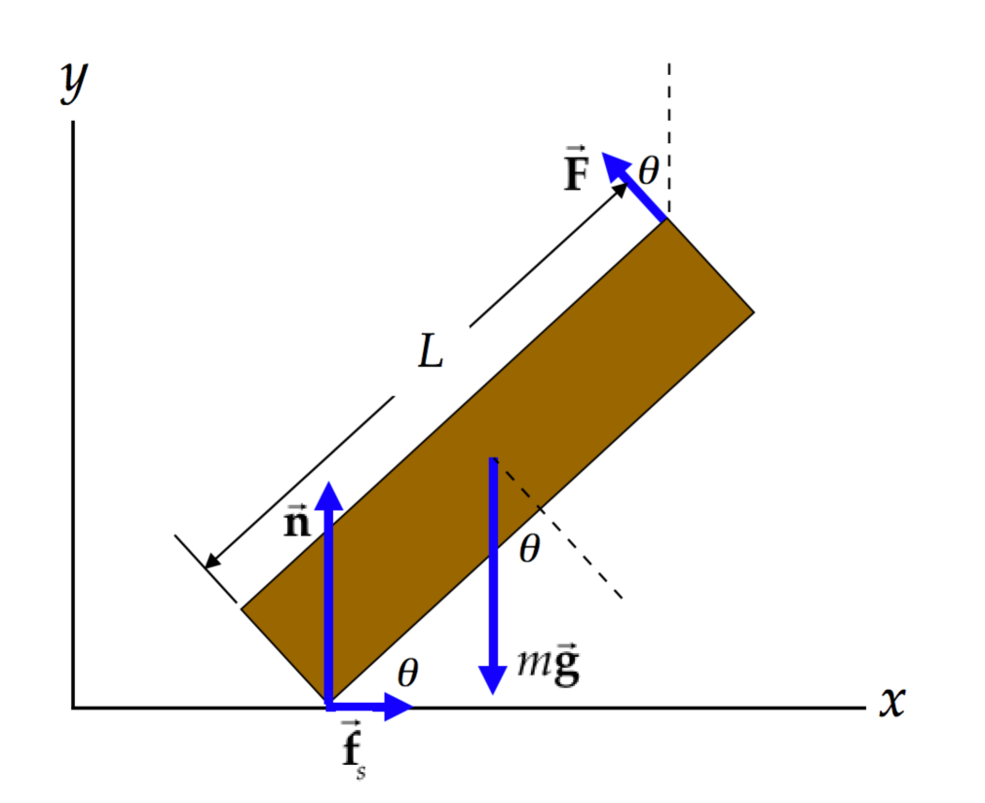

The force  is the force applied by the worker, always perpendicular to the crate. Write the equations for translational equilibrium in the horizontal and vertical directions:



Now write the equation for rotational equilibrium, taking torques about the point of contact of the crate with the floor:



Let’s impose the situation that we do not want the crate to slip. We can do that by requiring that the static friction force be less than its maximum value:

 (4)

Incorporating Equation (1), we have

 (5)

This condition tells us that the coefficient of static friction must be larger than a certain value to prevent the crate from slipping. But we don't know *F*, *n*, or **. From Equations (2) and (3), however, we have



Substituting Equation (7) into Equation (6), we have



Substitute Equations (7) and (8) into the inequality in Equation (5):

 (9)

Let’s look at the limiting condition. Change the sign in Equation (9) from a “greater than” sign to an equal sign and find the limiting angle:



Equation (10) is a quadratic equation in sin2**. Using the quadratic formula,



Substitute the value of *s*:



Therefore, once the worker lifts the crate to an angle of 28.1°, it is going to slip; the slipping cannot be avoided. In fact, for any angle between 28.1° and 43.1°, the crate is going to slip.

**Finalize** The right-hand side of Equation (9) can be shown to maximize at 0.354, at an angle of about 35.3°. (Set the square root in Equation (11) equal to zero so that there is no *range* of angles at which the crate will slip.) If the floor had a coefficient of static friction above this value, the crate could be successfully tipped up on its end without slipping. Therefore, a suggestion might be to coat the factory floor with a rougher surface.

*Answer:* When the crate reaches an angle of 28.1° with respect to the floor, it slips.

P12.47 (a) Consider the torques about an axis perpendicular to the page through the left end of the rod, as shown in ANS. FIG. P12.47.



then,



(b) From the first condition for equilibrium,



Similarly,



which gives



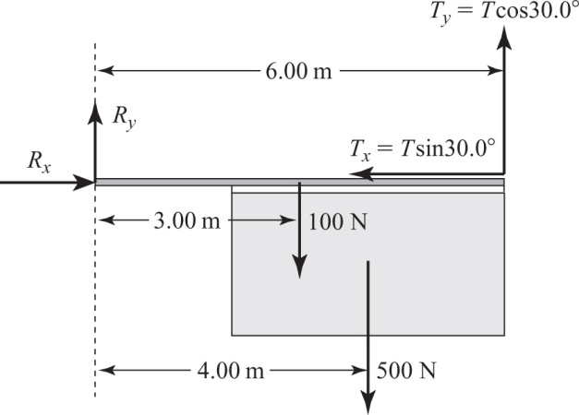

**ANS. FIG. P12.47**

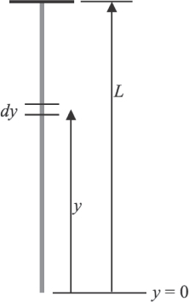**P12.48** Let the original length (when the cable is laid horizontally on a frictionless surface) of an infinitesimal piece of the cable be *dy*. Let the extension of this piece be *dL* when the cable is hung vertically. Then, for the entire cable,



where *F* is the weight of the cable below a point at position *y*. Evaluating *F*, with  as the mass per unit length,

**ANS. FIG. P12.48**





**Challenge Problems**

**P12.49** (a) Just three forces act on the rod: forces perpendicular to the sides of the trough at A and B, and its weight. The lines of action of the normal forces at A and B will intersect at a point above the rod so that those forces will have no torque about this point. The rod’s weight will cause a torque about the point of intersection as in ANS. FIG. P12.49 (a), and the rod will not be in equilibrium unless the center of the rod lies vertically below the intersection point, as in ANS. FIG. P12.49 (b). All three forces must be concurrent. Then the line of action of the weight is a diagonal of the rectangle formed by the two normal forces, and the rod’s center of gravity is vertically above the bottom of the trough.

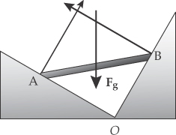

**ANS. FIG. P12.49 (a)**

(b) In ANS. FIG. P12.49(b),  and



So  and 

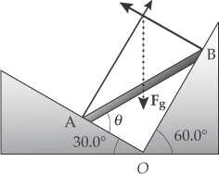

**ANS. FIG. P12.49 (b)**

(c)  If the rod is displaced slightly, it will slip until it lies along the left edge of the trough where its center of gravity will be lower.

**P12.50** Consider forces and torques on the beam.



(a) Suppressing units, we find



(b) From substituting back,



Dividing,





(c) To find *R* we can work out  From the expressions above for  and 



(d) 

|  |
| --- |
| **ANSWERS TO QUICK-QUIZZES** |

**1.** (a)

**2.** (b)

**3.** (b)

**4. (i)** (b) **(ii)** (a) **(iii)** (c)

|  |
| --- |
| **ANSWERS TO EVEN-NUMBERED PROBLEMS** |

P12.2 The situation is impossible because *x* is larger than the remaining portion of the beam, which is 0.200 m long.

P12.4 

P12.6 (a) 27.7 kN (b) 11.5 kN (c) 4.19 kN

P12.8 (a) See ANS. FIG. P12.8; (b)  (c) T = *µsmg*; (d)    
(e) The ladder slips

P12.10 (a) See ANS. FIG. P12.10; (b) 392 N; (c) 339 N to the right; (d) 0;   
(e) *V* = 0; (f) 392 N; (g) 339 N to the right; (h) The two solutions agree precisely. They are equally accurate.

P12.12 (a) No time interval. The horse’s feet lose contact with the drawbridge as soon as it begins to move; (b) 1.73 rad/s; (c) 2.22 rad/s; (d) 6.62 kN. The force at the hinge is ; (e) 59.1 kJ

P12.14 (a) See ANS. FIG. P12.14; (b) 218 N; (c) 72.4 N; (d) 2.41 m; (e) See P12.14(e) for full explanation.

P12.16 (a) 

(b) 

P12.18 ~ 1 cm

P12.20 1.0 × 1011 N/m2

P12.22 1.65 × 108 N/m2

P12.24 (a) Rigid object in static equilibrium; (b) See ANS. FIG. P12.24; (c) The woman is at *x* = 0 when *n*1 is greatest; (d) *n*1 = 0; (e) 1.42 × 103 N;   
(f) 5.64 m; (g) same as answer (f)

P12.26 (a) 66.7 N (b) increasing at 0.125 N/s

P12.28 (a) See ANS. FIG. P12.28 for the force diagram and see P12.28 (a) for a sample problem statement. (b) The upper hinge exerts 410 N to the left and 442 N up. The lower hinge exerts 410 N to the right.

P12.30 *T* = 1.46 kN; *H* = 1.33 kN; *V* = 2.58 kN

P12.32 *θ* = 21.2°; *T* = 1.68 kN; *R* = 2.34 kN

P12.34 (a) 2.71 kN; (b) 2.65 kN; (c) You should lift “with your knees” rather than “with your back”; (d) In this situation, you can make the compressional force in your spine about ten times smaller by bending your knees and lifting with your back as straight as possible.

P12.36 The situation is impossible because the new technique would tip the cabinet over.

P12.38 (a) *n*C = 634 N, *n*A = 1 000 N – *n*C = 366 N; (b) *CAB* = 732 N, *TAC* = 634 N, and *CBC* = 897 N

P12.40 (a) *T* = 133 N; (b) *n*A = 429 N, *n*B = 257 N; (c) *Rx* = 133 N, to the right,   
*Ry* = 257 N, downward

P12.42 

P12.44 (a and b) 120 N, 0.300; (c) 103 N applied at 31.0° above the horizontal at the upper left corner.

P12.46 When the crate reaches an angle of 28.1° with respect to the floor, it slips.

P12.48 4.90 cm

P12.50 (a) 93.9*d* + 125, in N; (b) See P12.50 (b) for full derivation; (c) See P12.50 (c) for full derivation; (d) As *d* increases, *T* grows larger, *θ* decreases, and *R* decreases until about *d* = 5.4 m, then it increases. Note as *d* increases, the *d*2 term predominates.